Modelio rezultatai prognozuojant '2025-01-09 04 (7.5 Sprint Competition) W':

precision recall f1-score support

0 0.90 0.80 0.85 35

1 0.63 0.80 0.71 15

accuracy 0.80 50

macro avg 0.77 0.80 0.78 50

weighted avg 0.82 0.80 0.81 50

Modelio rezultatai prognozuojant '2024-12-04 01 (12.5 Short Individual) W':

precision recall f1-score support

0 0.90 0.78 0.84 36

1 0.58 0.79 0.67 14

accuracy 0.78 50

macro avg 0.74 0.78 0.75 50

weighted avg 0.81 0.78 0.79 50

Modelio rezultatai prognozuojant '2025-01-11 04 (10 Pursuit Competition) W':

precision recall f1-score support

0 0.93 1.00 0.97 42

1 1.00 0.62 0.77 8

accuracy 0.94 50

macro avg 0.97 0.81 0.87 50

weighted avg 0.94 0.94 0.93 50

Modelio rezultatai prognozuojant '2025-01-16 05 (15 Individual Competition) W':

precision recall f1-score support

0 0.81 0.97 0.88 31

1 0.92 0.63 0.75 19

accuracy 0.84 50

macro avg 0.87 0.80 0.82 50

weighted avg 0.85 0.84 0.83 50

Modelio rezultatai prognozuojant '2025-01-19 05 (12.5 Mass Start Competition) W':

precision recall f1-score support

0 0.96 1.00 0.98 46

1 1.00 0.50 0.67 4

accuracy 0.96 50

macro avg 0.98 0.75 0.82 50

weighted avg 0.96 0.96 0.95 50

Modelio rezultatai prognozuojant '2025-01-23 06 (7.5 Sprint Competition) W':

precision recall f1-score support

0 0.85 0.90 0.88 31

1 0.82 0.74 0.78 19

accuracy 0.84 50

macro avg 0.84 0.82 0.83 50

weighted avg 0.84 0.84 0.84 50

Modelio rezultatai prognozuojant '2025-01-25 06 (10 Pursuit Competition) W':

precision recall f1-score support

0 0.95 0.95 0.95 42

1 0.75 0.75 0.75 8

accuracy 0.92 50

macro avg 0.85 0.85 0.85 50

weighted avg 0.92 0.92 0.92 50

2025-03-23 10 (12.5 Mass Start Competition) W dalyvavimo prognozes svarbiausi pozymiai

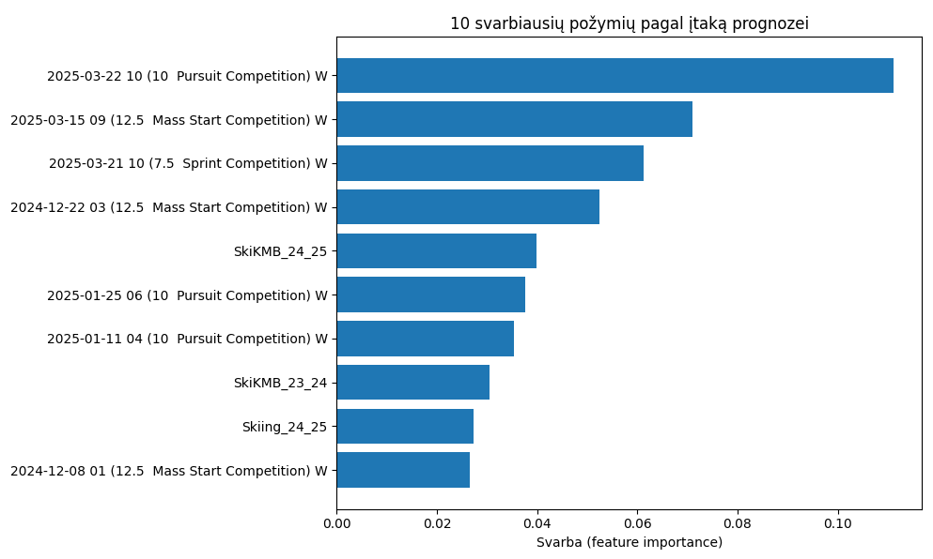

2024-01-05 04 (7.5 Sprint Competition) W etapo dalyvavimo prognozes svarbiausi pozymiai

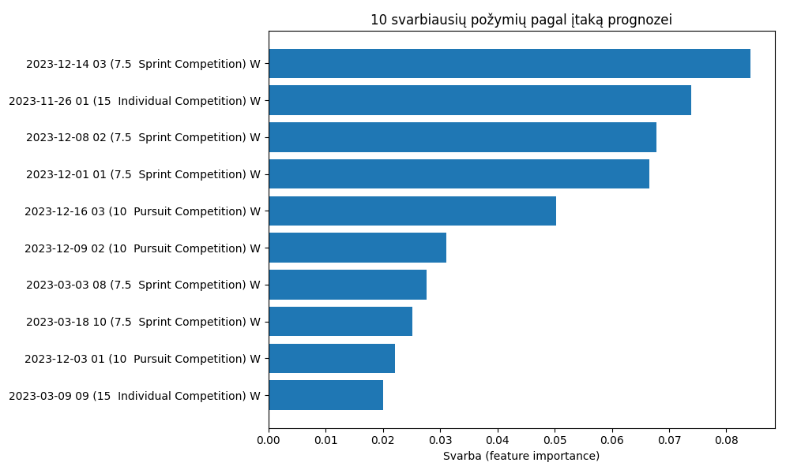

2024-01-05 04 (7.5 Sprint Competition) W etapo vietos prognozes svarbiausi pozymiai

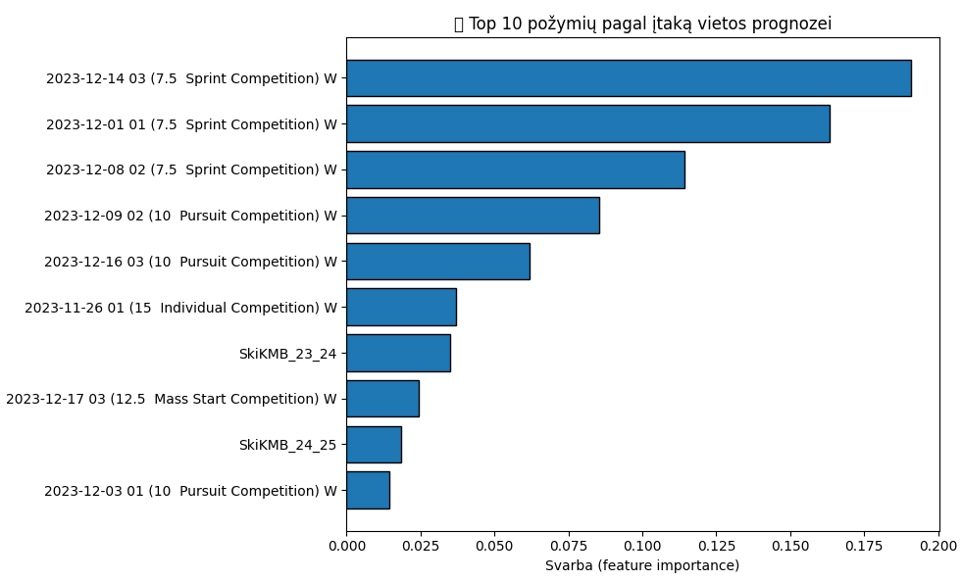

F1 priklausomybė nuo n-estimators

